**ER Diagram**

* **What is an ER Diagram ?**

An Entity Relationship (ER) Diagram is a type of flowchart that illustrates how “entities” such as people, objects or concepts relate to each other within a system.

* **ER diagram for college management system :**

1. **Diagram:**

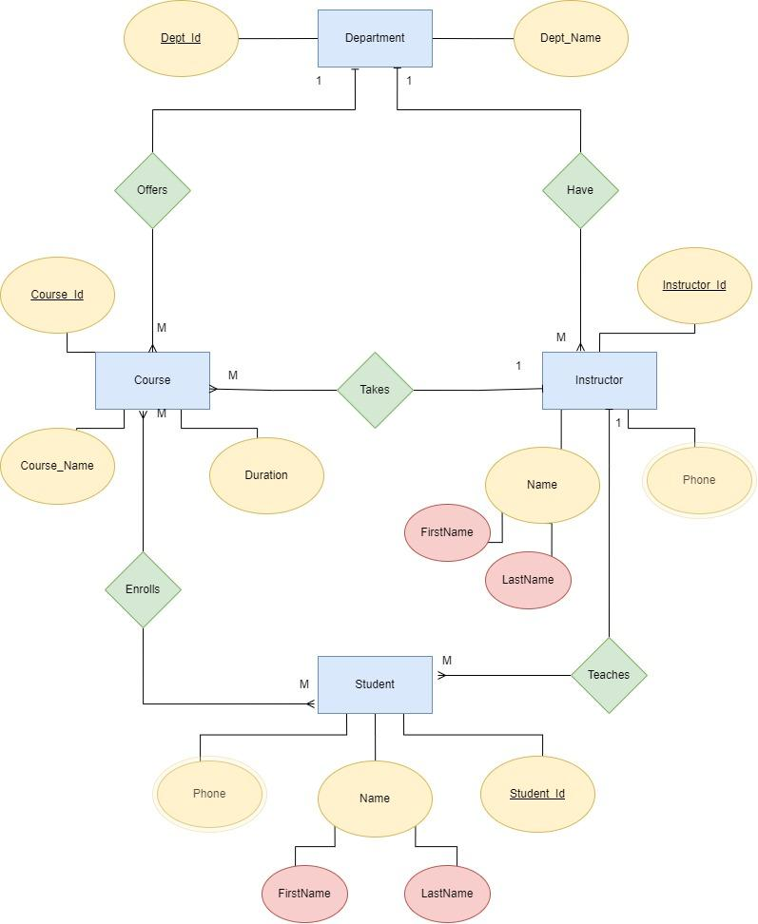

1. **Insights from the diagram:**
2. One Department can have multiple instructors
3. An instructor can take many courses
4. An instructor can teach many students
5. Students can enroll in any number of courses
6. Department offers many courses

**3) Entities:**

1. Department
2. Courses
3. Instructor
4. Student

**4) Defining Attributes:**

1. **Department:**
2. Department_Id(Key Attribute)
3. Department_Name

**b) Instructor:**

1. Instructor_Id(Key Attribute)
2. Instructor_Name
3. FirstName
4. LastName
5. Phone

**c) Courses:**

1. Course_Id(Key Attribute)
2. Course_Name
3. Duration

**d) Student:**

1. Student_Id(Key Attribute)
2. FirstName
3. LastName
4. Phone

**5) Minimization of diagram into table:**

1. **A department has many instructor:**

Department(Dept_name)

Instructor(Instructor_Id, FirstName, LastName)

Instructor(Instructor_Id, Phone)

Relation : 1 to M

Has(Instruction_Id, Dept_Name, FirstName, LastName, Phone)

1. **A department offers many courses:**

Department(Dept_name)

Course(Course_Id, Course_Name, Duration)

Relation : 1 to M

Offers(Course_Id, Dept_Name, Course_Name, Duration)

1. **A instructor teaches many courses:**

Course(,Course_Id, Course_name, Duration)

Instructor(Instructor_Id, FirstName, LastName)

Instructor(Instructor_Id, Phone)

Relation : 1 to M

Takes(Course_Id, Instruction_Id, Course_name, Duration)

1. **A instructor teaches many students:**

Student(Student_Id, FirstName, LastName)

Student(Student_Id, Phone)

Instructor(Instructor_Id, FirstName, LastName)

Instructor(Instructor_Id, Phone)

Relation : 1 to M

Teaches(Student_Id, Instruction_Id, FirstName, LastName, Phone)

1. **A student enrolls in many courses:**

Student(Student_Id, FirstName, LastName)

Student(Student_Id, Phone)

Course(,Course_Id, Course_name, Duration)

Relation : M to M

Enrolls(Student_Id, Course_Id)

**Using mysql:**

mysql> create table depart_offers_course(course_id int not null, foreign key(course_id) references course(course_id),dept_id int not null, foreign key(dept_id) references department(dept_id), course_name varchar(255), duration int);

Query OK, 0 rows affected (0.05 sec)

mysql> show tables;

+-------------------------------------+

| Tables_in_college_management_system |

+-------------------------------------+

| course |

| depart_offers_course |

| department |

+-------------------------------------+

3 rows in set (0.01 sec)

mysql> create table instructor_table_1(Instructor_id int not null primary key, firstname varchar(255), lastname varchar(255));

Query OK, 0 rows affected (0.04 sec)

mysql> create table instructor_table_2(Instructor_id int not null, foreign key(instructor_id) references instructor_tale_2(Instructor_Id), phone int);

ERROR 1824 (HY000): Failed to open the referenced table 'instructor_tale_2'

mysql> create table instructor_table_2(Instructor_id int not null, foreign key(instructor_id) references instructor_table_2(Instructor_Id), phone int);

ERROR 1822 (HY000): Failed to add the foreign key constraint. Missing index for constraint 'instructor_table_2_ibfk_1' in the referenced table 'instructor_table_2'

mysql> create table instructor_table_2(Instructor_id int not null, foreign key(instructor_id) references instructor_table_1(Instructor_Id), phone int);

Query OK, 0 rows affected (0.05 sec)

mysql> create table dapartment_has_instructor(Instructor_Id int not null, foreign key(Instructor_Id) references Instructor_Table_1(Instructor_Id), Dept_Id int not null, foreign key(Dept_Id) references Department(Dept_Id), FirstName varchar(255), LastName varchar(255), Phone int, foreign key(Instructor_Id) references Instructor_Table_2(Instructor_Id));

Query OK, 0 rows affected (0.05 sec)

mysql> create table Instructor_teaches_Courses(Course_id int not null, foreign key(Course_id) references Courses(Course_Id), Instructor_Id int not null, foreign key(Instructor_Id) references Instructor_Table_1(Instructor_Id), Course_name varchar(255), Duration int);

ERROR 1824 (HY000): Failed to open the referenced table 'courses'

mysql> create table Instructor_teaches_Courses(Course_id int not null, foreign key(Course_id) references Course(Course_Id), Instructor_Id int not null, foreign key(Instructor_Id) references Instructor_Table_1(Instructor_Id), Course_name varchar(255), Duration int);

Query OK, 0 rows affected (0.05 sec)

mysql> create table Student_Table_1(Student_Id int not null Primary Key, FirstName varchar(255), LastName(255));

ERROR 1064 (42000): You have an error in your SQL syntax; check the manual that corresponds to your MySQL server version for the right syntax to use near '(255))' at line 1

mysql> create table Student_Table_1(Student_Id int not null Primary Key, FirstName varchar(255), LastName varchar(255));

Query OK, 0 rows affected (0.04 sec)

mysql> create table Student_Table_2(Student_Id int not null Primary Key, Phone int);

Query OK, 0 rows affected (0.04 sec)

mysql> drop Student_Table_2;

ERROR 1064 (42000): You have an error in your SQL syntax; check the manual that corresponds to your MySQL server version for the right syntax to use near 'Student_Table_2' at line 1

mysql> drop table Student_Table_2;

Query OK, 0 rows affected (0.03 sec)

mysql> create table Student_Table_2(Student_Id int not null, foreign key(Student_Id) references Student_Table_1(Student_Id), Phone int);

Query OK, 0 rows affected (0.05 sec)

mysql> create table Instructor_teaches_Students(Student_Id int not null, Instructor_Id int not null, FirstName varchar(255), LastName varchar(255), Phone int, foreign key(Student_Id) references Student_Table_1(Student_id), foreign key(Student_Id) references Student_Table_2(Student_id), foreign key(Instructor_Id) references Instructor_Table_1(Instructor_id), foreign key(Instructor_Id) references Instructor_Table_2(Instructor_id));

Query OK, 0 rows affected (0.06 sec)

mysql> create table Student_Enrolls_Course(Student_Id int not null, Course_Id int not null, foreign key(Student_Id) references Student_Table_1(Student_id), foreign key(Student_Id) references Student_Table_2(Student_id), foreign key(Course_Id) references Course(Course_id));

Query OK, 0 rows affected (0.06 sec)

mysql> show tables;

+-------------------------------------+

| Tables_in_college_management_system |

+-------------------------------------+

| course |

| dapartment_has_instructor |

| depart_offers_course |

| department |

| instructor_table_1 |

| instructor_table_2 |

| instructor_teaches_courses |

| instructor_teaches_students |

| student_enrolls_course |

| student_table_1 |

| student_table_2 |

+-------------------------------------+

11 rows in set (0.00 sec)

mysql>